**Name of the paper** : Development of an Android application for viewing Covid-19 containment zones and monitoring violators who are trespassing into it using Firebase and Geofencing.

**Published Year** : 2020

**Author** :

Ranajoy Mallik · Amlan Protim Hazarika · Sudarshana Ghosh Dastidar · Dilip Sing · Rajib Bandyopadhyay

**Topic** : Containment Zone Altering Application

**Disadvantage** :

The Cloud Firestore does not always fetch data from the database unless the data has been changed, it gathers previous data from the cache memory which also enables its offline functioning.

So how great is the risk that patient confidentiality will be compromised?

**Limitations** :

Identifying an infected person is more difficult when the other person has not a Bluetooth-enabled phone or is having no smartphone at all.

A problem may also arise if other users have not made their Bluetooth visibility detectable to nearby devices.

Many users have found this app buggy and had reported with login issues.

With more stress out on user’s privacy and widespread of the pandemic,

Mountains of user data is one the edge of exposure.

This apps seems inadequate to find out symptoms in the patients who were affected by Coronavirus earlier and recovered later.

On the flip side, even the leading nations have no further provisions or backup continuity plan to handling bulk user data which may lead to critical server issues like data handling and redundancies.

**Overall interference** :

Currently there are several research works undergoing in the country to prevent Covid-19 cases from rising. Previously our country was importing medical kits like PPE (Personal Protection Kits), mask from outside, but now it has been successful in developing these kits. Along with taking initiatives to fight this disease, our country has also taken steps to make people aware of the disease. The news and media have a great part in creating this awareness by informing the public about the preventive measures that can keep them away from infection. Awareness among the people to carry out all the preventive measures can immensely help to reduce spread of the virus.

There are mainly three activities in the application. The first activity consists of a welcome screen which is designed with images and information. Next activity is a screen displaying the instructions to operate the application and a disclaimer. The third activity is a maps activity which

shows all the containment zones in a google map This activity also has a bottom sheet which can be pulled up to show the real time Covid-19 statistic of West Bengal.

Geofencing API from Android is used to create virtual boundaries or fences around geographical locations (Create and monitor geofences 2020). The developers can add geofences at different locations by providing the latitudes and longitudes along with radius to define the virtual boundary at that location. Geofencing technology senses the user’s current location and checks whether the location is inside any of the geofences created. A broadcast receiver receives intent contained in a pendingintent (an android API) sent by the location services when the user has entered, dwelt, or exited a geofence and can initiate a background work or send a notification. The geofence transitions events include enter, exit, and dwell and multiple transition events can be set for the geofences. In this application, the dwell transition is set for the containment zones with a loitering delay of 5 seconds and an expiration duration set to never expire. The broadcast receiver is set to initiate a notification by the notification manager upon receiving an intent. Once the geofences are set, the user would receive notification on entering and dwelling inside a containment zone.

The application provides an effcient way of showing the identified Covid-19 containment zones to the users in a Google map. With the alarming increase of Covid-19 affected cases throughout the world, this developed application can be employed as a tool for creating further social awareness among the people. This application further tracks the user’s location and checks whether it is present in the list of identifed containment zones. It sends separate notification alerts to the user on entering. The developed android application further extracts the IMEI Number of the trespasser in the containment zones which can be useful to the local police to track and identify people who are frequently trespassing the containment zones. Thereby this application identifes the containment zones and highlights the need for taking further precautionary measures for combating Covid19. The application has been tested in various locations and has been found to yield accurate results. The application can be further used for many purposes like maritime and forest safety to prevent users from entering restricted areas

**Name of the topic: Digital technologies in the public-health response to COVID-19**

**Published Year:2020** **Author:**

Jobie Budd, Benjamin S. Miller, Erin M. Manning, Vasileios Lampos

**Topic: Containment Zone Alerting System Disadvantage:**

* The app requires Bluetooth and GPS to be switched on all the time, and takes admin access for the Bluetooth settings. Admin access on devices is a security risk as the application can take more data than required.
* Identifying an infected person is more difficult when the other person has not a Bluetooth-enabled phone or is having no smartphone at all.
* A problem may also arise if other users have not made their Bluetooth visibility detectable to nearby devices.

# Limitations:

* Purpose limitation has become a key point of concern among civil society activists — that the app could be used beyond the purpose it was created for and evolve into a “permanent architecture” without clarity and limits. “It becomes problematic when there is collating of data on the central server, and once that gets entangled with other databases.
* if the location of users can be identified via the app, the government could use this information to analyse the types of locations and businesses users are frequenting and target lockdown restrictions accordingly. This could have a disproportionate impact on businesses in certain sectors which receive a high level of footfall, particularly retail.

# Overall interference:

Digital technologies are being harnessed to support the public-health response to COVID-19 worldwide, including population surveillance, case identification, contact tracing and evaluation of interventions on the basis of mobility data and communication with the public. These rapid responses leverage billions of mobile phones, large online datasets, connected devices, relatively low-cost computing resources and advances in machine learning and natural language processing. This Review aims to capture the breadth of digital innovations for the public-health response to COVID-19 worldwide and their limitations, and barriers to their implementation, including legal, ethical and privacy barriers, as well as organizational and workforce barriers. The future of public health is likely to become increasingly digital, and we review the need for the alignment of international strategies for the regulation, evaluation and use of digital technologies to strengthen pandemic management, and future preparedness for COVID-19 and other infectious diseases. Many approaches use a combination of digital technologies and may rely on telecommunications infrastructure and internet availability.

Machine learning is shown as a separate branch for clarity, although it also underpins many of the other technologies. Much of the data generated from these technologies feeds into data dashboards. SMS, short message service. Digital contact tracing automates tracing on a scale and speed not easily replicable without digital tools. It reduces reliance on human recall, particularly in densely populated areas with mobile populations. In the COVID-19 pandemic, digital contact-tracing apps have been developed for use in several countries; these apps rely on approaches and technologies not previously tried on this scale and are controversial in terms of privacy. Evaluating their accuracy and effectiveness is essential.

Early digital tracing initiatives raised concerns about privacy. In South Korea, contacts of confirmed cases were traced through the use of linked location, surveillance and transaction data. In China, the AliPay , HealthCode app automatically detected contacts by concurrent location and automated the enforcement of strict quarantine measures by limiting the transactions permitted for

users deemed to be high risk. More-recent voluntary contact-tracing apps have been launched in collaboration with governments; these collect location data by global positioning system (GPS) or cellular networks, proximity data collected by

Bluetooth or a combination of those Concerns have been raised about centralized systems and GPS tracking. Norway halted the use of and data collection from its Smittestopp app after the country’s data-protection watchdog objected to the app’s

collection of location data as ‘disproportionate to the task’, and they recommended a Bluetooth-only approach. Several international frameworks with varying levels of privacy preservation are emerging, including Decentralized Privacy-Preserving Proximity Tracing, the Pan-European Privacy-Preserving Proximity Tracing

initiative and the joint Google–Apple framework.

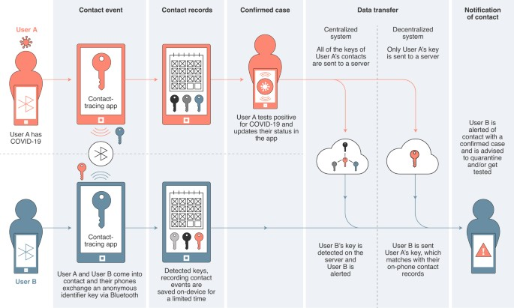**Contact tracing for COVID-19 with Bluetooth-enabled smartphone apps.**

**Conclusion:**

The COVID-19 pandemic is ongoing, and it is too early to fully quantify the added value of digital technologies to the pandemic response. While digital technologies offer tools for supporting a pandemic response, they are not a silver bullet. The emerging consensus is that they have an important role in a comprehensive response to outbreaks and pandemics, complementing conventional public-health measures, and thereby contribute to reducing the human and economic impact of COVID-19. Cost-effectiveness and sustainability will require systems-level approaches to building digital online care pathways that link rapid and widespread testing with digital symptom checkers, contact tracing, epidemiological intelligence and long-term clinical follow up. The COVID-19 pandemic has confirmed not only the need for data sharing but also the need for rigorous evaluation and ethical frameworks with community participation to evolve alongside the emerging field of mobile and digital healthcare. Building public trust through strong communication strategies across all digital channels and demonstrating a commitment to proportionate privacy are imperative.

**Name of the paper** : Research and development of a COVID-19 tracking system in order to implement analytical tools to reduce the infection risk

**Published year** : 2022

**Author** :

* + **Juraj Nevrela ,** Head of Department at Desidia tech
  + **Erik Vavrinsky** , Professor at Slovak University of Technology in Bratislava

**Topic** : Containment Zone Alerting Application

## Disadvantages :

With more stress out an User’s privacy and widespread of pandemic , Mountains of user data is one of the edge of exposure.

Some privacy campaginers have objected to the bulk of their details by the government authorities.

## Limitations :

1. The downside is, contact tracing apps potentially pose considerable privacy concerns. This means it is important for governments and app developers to not lose sight of protecting user privacy and not to verge into what could amount to surveillance. Privacy is crucial when deploying technological solutions that involve the processing of sensitive personal data.
2. Only by ramping up testing of asymptomatic individuals can we avoid the inherent delays that limit the efficacy of contact tracing.

## Overall inference

Global interconnections bring today not only great benefits but also significant risks.

One of them is the rapid spread of infectious diseases in the population, as we have

seen recently. The World Health Organization (WHO) has issued a series of recommendations to slow down the spread of COVID-19. In particular, they discussed the necessity to reduce

social activity and maintain physical distance. Many countries began to implement social distancing and different forms of lockdowns . However, in certain situations, it is impossible to maintain limited contact between people. The world continues to move, and everyone has to meet their living needs. The risk of infection is high in these interpersonal relationships. In particular, infected people who have not been positively identified and are asymptomatic carriers pose a risk . In Slovakia and many other countries, the persons

who have recently come into direct contact with a positively tested person are contacted by healthcare staff. If they are not vaccinated, they are subsequently sent to quarantine and undergo a polymerase chain reaction (PCR) test. The disadvantage of this early warning system is the incomplete capture of carriers. It is practically impossible to detect asymptomatic individuals who do not know they are transmitting the virus and warn anonymous foreign people who have met the infected person. Additionally, the current overloaded situation precludes this manual tracking and makes it almost impossible and prone to human error.

The Faculty of Electrical Engineering and Information Technology at the Slovak University of Technology in Bratislava and the Jessenius Faculty of Medicine in Martin, Comenius University, began to develop technical and methodological procedures to slow the spread of the disease

and monitor positive patients or people exposed to the virus . Their aim was to develop an automated contact tracking system using portable devices, which allows more reliable

tracking of anonymous social interactions and is attractive for people. People exposed to a positive person at a time when the person did not yet know about the virus infection will be additionally informed of the situation and level of threat and advised to take the necessary steps to prevent the transmission of COVID-19 and reduce the reproductive number.

The alternative is using a decentralized network of devices , working

on the principle of proximity detection . Interaction data are encrypted and can potentially be disseminated as a blockchain. The advantage is the security and anonymity of the

system, but the potentially long time to spread data over this type of network is a major

disadvantage. Moreover, due to the limited range of communication, such a system will become effective only with a higher percentage of devices in the population.

After the implementation of appropriate evaluation algorithms and neural networks, the system will be a powerful tool to suppress the spread of infectious diseases. The methodology was granted a utility model. In the future, we plan to expand the system with other sensors of human physiology such as heart rate and blood oxygenation. After their implementation, a certain version of the Holter will be actually created. An added measurement device of human physiology can make the device even more attractive for individuals. As a result, people will become interested in the device,

and the need to convince people of the benefits of the product will be reduced.

### Name of the paper:

A Detection, Tracking and Altering system for COVID -19 using Geofencing and Machine learning.

**Published year:** 2021.

### Authors:

Dipali Koshti, Supriya Kamoji, Kevin Cheruthuruthy, Surya Pratap Shahi, Mayank Mishra.

**Topic:** Containment Zone Alerting Application.

### Disadvantage:

Where many believe that Coronavirus Tracking apps are an effective tool to mitigate the outbreak, technologists also warn that apps may not be as effective as actually testing the population.

On the flip side, even the leading nations have no further provisions or backup continuity plan to handling bulk user data which may lead to critical server issues like data handling and redundancies.

### Limitations:

1. Network is an issue in some areas we cannot make all the people to use this application.
2. Symptomatic quiz should have all the languages otherwise it is crucial to establish this application among illiterate people.
3. At the same time covid may be asymptomatic too we cannot assure that with a quiz but we can know the severity of the covid.

**Overall Inference**

This is a application that uses Geofencing and Machine learning together to combat the spread of Coronavirus. The first fold is a Detection System for a user to undergo a Symptomatic Quiz based on a Risk Assessment ML Model to detect the presence of Covid in the user’s body. The second fold is an efficient Tracking system that uses Geofencing technology to keep track of all the people who come into contact with the user. And the third fold is an Alerting system that sends the alert message to all those people who came into contact with the user. The whole process of backtracking is the virus is called

“contact tracing”.

The system has been developed to satisfy the following core objectives:

1. Using Machine Learning algorithm and appropriate credible Database from official sources, to create an efficient Symptomatic Quiz that predicts the possibility of Corona with the highest possible accuracy.
2. Creating the perfect contact-tracing and alerting system to replace the manual procedure done by Medical Volunteers under the Ministry of Health and Family Welfare in the country.
3. Provide Medical Assistance to the people who seek Statistical Reports, Medical Emergency Assistance or Precautions to undertake in regards to Covid

-19.

On the basis of Data Collected from positive & negative Corona tested patients, there is a Symptomatic Analysis Quiz carried out by the user. This helps the user to find out the presence of the Corona virus in the user’s body. If a user is diagnosed Covid positive after getting a proper laboratory testing, the Covid positive user notifies the system about being Covid Positive. Followed by which, the system initiates notifications to all those who the Covid Positive user came in contact with in the past few days. This app boots the inbuilt function of Geofencing on the application which creates a geo-fence around the user and also broadcasts him/her to the other users around him. Other users that come in close contact with this user by infiltrating his fence have their IDs exchanged with this user. Their Associated Risk labelled earlier will be stored in the database and if they are Corona Positive with respect to the application, then an alert will be signalled to the user.

Whenever a user presses the “Step Out” button, the application asks the user to access his/her location. Based on that location, our application performs the tracking function. The location of the user is updated in our firebase database every time it changes and thus tracking the user and also maintaining the database of their location which is used in further processes. Based on this location and the results of the above-mentioned quiz, the application will create “hotspots” for all users to identify the possible areas which might be risky to visit.

The usage of XG Boost Algorithm stands out to create a machine learning model that provides the highest accuracy for covid risk prediction on a large data set. Geofencing being used in a first of its kind application plays a vital role in Contact Tracing Front. This, overall curbs the potential of massive transmission of the Corona Virus, thus creating an efficient Health care system.

## Name of the Topic: Application for Covid-19 Real Time Counter Published Year: 2022

**Author:** Omkar Dhok, Yash Dasouni, Harsh Dubey, Prasanna More

**Topic :** Containment Zone alerting Application

## Disadvantages:

* Bluetooth Tracker include the inability of the technology to track the physical location of the person. It will basically pick up the signals of nearby phones at 5-minute intervals and then store the connection between them in the database.
* people living in neighbourhood or in adjacent areas who in reality are not sharing the space with the user can put people in unnecessary tension, due to false detection since, no sort of technology whatsoever can conduct physical tests, it can only warn people.

## Limitations:

* However, ethical implications might arise due to possible conflicts between liberty and privacy and justice In this direction, health outcomes that have scarcely been used so far, such as infection rate and quality of life.
* As the number of cases increases suddenly, the contact tracing system will put under a heavier load which may leads to server failure.

# OverAll Inference

* The World Health Organization has declared the outbreak of the novel coronavirus, Covid-19 as pandemic across the world. With its alarming surge of affected cases throughout the world, lockdown, and awareness (social distancing, use of masks etc.) among people are found to be the only means for restricting the community transmission. . In a densely populated country like India, it is very difficult to prevent the community

transmission even during lockdown without social awareness and precautionary measures taken by the people. Recently, several containment zones had been identified throughout the country and divided into red, orange and green zones, respectively.

* Development of an Android application is necessary which can inform people of the Covid-19 containment zones and prevent trespassing into these zones. This Android application updates the locations of the areas in a Google map which are identified to be the containment zones. The application also notifies the users if they have entered a containment zone and upload the details of individual in online database.
* Mobile apps can help Government in solving several COVID-19–related challenges by increasing the reach of reliable information to both citizens and health professionals, decreasing misinformation and

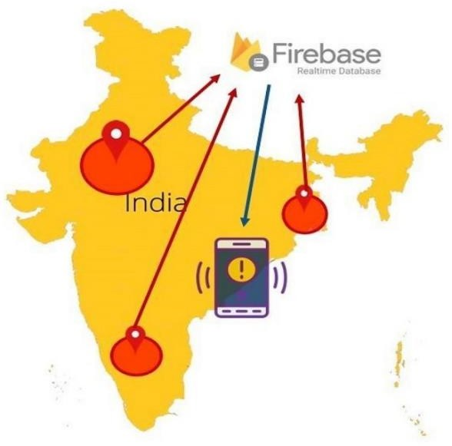confusion, tracking symptoms and mental health of citizens, home monitoring and isolation, discovering new predictors, optimizing health care resource allocation, and reducing the burden of hospitals. The dataset obtained from the application can be used for predictive analysis to determine prone areas and include special method for tackling the problem in those areas.

* + The application uses cloud Firestore which supports serverless app architecture where the application connects to the Cloud Firestore database directly without any intermediate servers in between. The Cloud Firestore features a NoSQL, document-oriented database and the data is stored in a JavaScript Object Notation (JSON) format. The location data are stored in documents, which are organized into collections. All the containment zones are stored in a collection in which each containment zone is represented as an individual document.
* Geofencing API from Android is used to create virtual boundaries or fences around geographical locations .The developers can add geofences at different locations by providing the latitudes and longitudes along with radius to define the virtual boundary at that location. Geofencing technology senses the user's current location and checks whether the location is inside any of the geofences created.